

S850/1

Subsidiary ICT

Paper 1

July/August, 2018

2½ hours

UGANDA MUSLIM TEACHERS’ ASSOCIATION

UMTA JOINT MOCK EXAMINATIONS – 2018

NAME…………………………………………………………………

INDEX NO…………………….SIGNATURE….…………………..

UGANDA ADVANCED CERTIFICATE OF EDUCATION

SUBSIDIARY ICT

PAPER I

**INSTRUCTIONS TO CANDIDATES:**

*Attempt* ***ALL*** *questions in this paper*

* *The maximum time allocated to this paper is 2 hours 30 Minutes*
* *The paper is made up of 20 equally weighted questions.*
* *Write in dark blue or black pen in the spaces provided on the Question Paper. All answers should be written in the spaces provided.*
* *No additional materials (answer sheets) are required.*
* *The number of marks is given in brackets ( ) at the end of each question or part question.*
* *The maximum mark for the paper is 100%*

|  |  |  |  |  |  |
| --- | --- | --- | --- | --- | --- |
| **FOR OFFICIAL USE ONLY** | | | | |  |
|  |  |  | 11. |  |  |
|  |  |  | 12. |  |  |
|  |  |  | 13. |  |  |
|  |  |  | 14. |  |  |
|  |  |  | 15. |  |  |
|  |  |  | 16. |  |  |
|  |  |  | 17. |  |  |
|  |  |  | 18. |  |  |
|  |  |  | 19. |  | **TOTAL** |
|  |  |  | 20. |  |  |

1. (a) Distinguish between data and information (2 Marks)

………………………………………………………………………………………………….

………………………………………………………………………………………………….

(b)Explain the importance of the three basic parts of the computer (3 Marks)

………………………………………………………………………………………………….

………………………………………………………………………………………………….

………………………………………………………………………………………………….

………………………………………………………………………………………………….

1. (a ) What is a computer competency? (1 Mark)

………………………………………………………………………………………………….

………………………………………………………………………………………………….

(b) Explain the four basic steps the computer processing cycle (4 Marks)

………………………………………………………………………………………………….

………………………………………………………………………………………………….

………………………………………………………………………………………………….

………………………………………………………………………………………………….

1. Explain the step of restoring a computer to and early date (5 Marks)

………………………………………………………………………………………………….

………………………………………………………………………………………………….

………………………………………………………………………………………………….

………………………………………………………………………………………………….

1. (a) In file management distinguish between save and save as (2 Marks)

………………………………………………………………………………………………….

………………………………………………………………………………………………….

(b) Briefly Describe a fragmented file (2 Marks)

………………………………………………………………………………………………….

………………………………………………………………………………………………….

(c) What is a file extension? (1 Mark)

………………………………………………………………………………………………….

………………………………………………………………………………………………….

1. Describe how you can create a folder on local disk C (5 Marks)

………………………………………………………………………………………………….

………………………………………………………………………………………………….

………………………………………………………………………………………………….

………………………………………………………………………………………………….

1. (a) Differentiate between a serial port and parallel port (2 Marks)

………………………………………………………………………………………………….

………………………………………………………………………………………………….

(b) Give an examples define the following terms (2 Marks)

(i) Optical storage media

………………………………………………………………………………………………….

………………………………………………………………………………………………….

(ii) Solid state storage media

………………………………………………………………………………………………….

………………………………………………………………………………………………….

(c) What is a key board? (1 Mark)

………………………………………………………………………………………………….

………………………………………………………………………………………………….

1. (a) Mention four reasons why an LCD monitor is preferred than a CRT Monitor

(4 Marks)

………………………………………………………………………………………………….

………………………………………………………………………………………………….

………………………………………………………………………………………………….

………………………………………………………………………………………………….

(b) List one advantage of using a compact disc other than a floppy disc

(1 Mark)

………………………………………………………………………………………………….

………………………………………………………………………………………………….

1. (a) Briefly describe how the following function
2. Optical mark recognition (2 Marks)

………………………………………………………………………………………………….

………………………………………………………………………………………………….

1. Optical character recognition (2 Marks)

………………………………………………………………………………………………….

………………………………………………………………………………………………….

(b)What is a biometric device? (1 Mark)

………………………………………………………………………………………………….

………………………………………………………………………………………………….

1. Explain any five resources that are managed and controlled by the operating system

………………………………………………………………………………………………….

………………………………………………………………………………………………….

………………………………………………………………………………………………….

………………………………………………………………………………………………….

………………………………………………………………………………………………….

………………………………………………………………………………………………….

1. Write the file extension for the file mention in the table below (5 Marks)

|  |  |
| --- | --- |
| Description | Extension |
| A video/Audio file |  |
| An image file |  |
| A Microsoft word document file |  |
| Files containing a series of commands loaded during boot |  |
| System files that perform fundamental operations in a computer |  |

1. (a) What is a software suit? (1 Mark)

………………………………………………………………………………………………….

………………………………………………………………………………………………….

(b) Explain why an operating system may fail to boot (2 Marks)

………………………………………………………………………………………………….

………………………………………………………………………………………………….

(c) List any two likely solutions to the problem in 11(b) above (2 Marks)

………………………………………………………………………………………………….

………………………………………………………………………………………………….

1. (a) Define the term Electronic mail (2 Marks)

………………………………………………………………………………………………….

………………………………………………………………………………………………….

(b) Explain the three basic elements of an e-mail compose window (3 Marks)

………………………………………………………………………………………………….

………………………………………………………………………………………………….

………………………………………………………………………………………………….

………………………………………………………………………………………………….

1. (a) State three advantages and two disadvantages of using the internet today

Advantages

………………………………………………………………………………………………….

………………………………………………………………………………………………….

………………………………………………………………………………………………….

Disadvantages

………………………………………………………………………………………………….

………………………………………………………………………………………………….

1. (a) Distinguish between a website and a blog (2 Marks)

………………………………………………………………………………………………….

………………………………………………………………………………………………….

(b) Briefly explain how you would browser to the ministry of Education and

sports website (3 Marks)

………………………………………………………………………………………………….

………………………………………………………………………………………………….

1. (a) What is computer networking? (1 Mark)

………………………………………………………………………………………………….

………………………………………………………………………………………………….

(b) What can your school benefit from networking of the school premises

(4 Marks)

………………………………………………………………………………………………….

………………………………………………………………………………………………….

………………………………………………………………………………………………….

………………………………………………………………………………………………….

1. (a) Explain the meaning of the term router ? (1 Mark)

………………………………………………………………………………………………….

………………………………………………………………………………………………….

(b) List any four factors that affect the rate of data transmission (4 Marks)

………………………………………………………………………………………………….

………………………………………………………………………………………………….

………………………………………………………………………………………………….

………………………………………………………………………………………………….

17. (a) illustrate two elements of green computing with the help of examples

………………………………………………………………………………………………….

………………………………………………………………………………………………….

(b) List three ways of implementing green computing

………………………………………………………………………………………………….

………………………………………………………………………………………………….

………………………………………………………………………………………………….

………………………………………………………………………………………………….

18. (a)Define the term cyber ethics (1 Mark)

………………………………………………………………………………………………….

………………………………………………………………………………………………….

(b) Mention four ways of protecting data on your computer (4 Marks)

………………………………………………………………………………………………….

………………………………………………………………………………………………….

………………………………………………………………………………………………….

………………………………………………………………………………………………….

1. The table below shows results of Bachelors of information technology

extracted from spreadsheet application. Use it to answer the questions (a) to

(c) below;

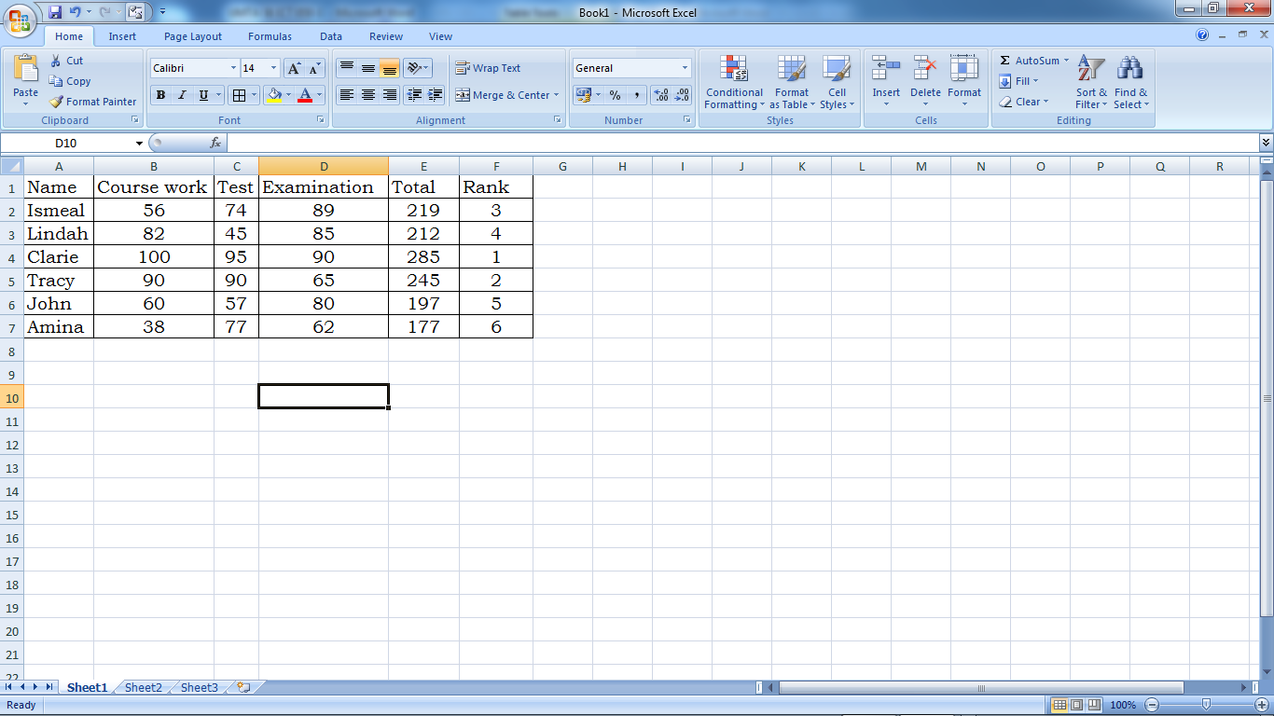

1. Write the formulae that was used to generate the totals (02 Marks)

………………………………………………………………………………………………….

………………………………………………………………………………………………….

1. Write the formulae that was used in Cell F4 to generate the rank

(02 Marks)

………………………………………………………………………………………………….

………………………………………………………………………………………………….

1. If rows are sorted in ascending order by Test, who will be at the top of the list? (01 mark)

………………………………………………………………………………………………….

………………………………………………………………………………………………….

20. The schools’ debate club keeps a file of members on a computer system. Part of

the file is shown in the following diagram.

|  |  |  |  |  |  |
| --- | --- | --- | --- | --- | --- |
| **ADMIN CODE** | **SURNAME** | **INITIAL** | **SEX** | **PHONE NO** | **DATE OF BIRTH** |
| FF024 | Namuli | NM | F | 0771458275 | 04/01/88 |
| FF067 | Namusoke | NZ | F | 0702584656 | 15/05/86 |
| FF078 | John | JP | M | 0705289678 | 18/02/87 |
| FF089 | Namusisi | MN | F | 0794582759 | 21/07/86 |
| FF045 | Ishimwe | A | M | 0714568927 | 09/02/88 |

(a) How many fields are there in table above? (2 Mark)

………………………………………………………………………………………………….

………………………………………………………………………………………………….

(b) State the data type that should be used for the Admin code data

………………………………………………………………………………………………….

………………………………………………………………………………………………….

(c) Outline one reason why the data in the sex field has been coded. (2 Marks)

………………………………………………………………………………………………….

………………………………………………………………………………………………….

(d) Mention one data type used in Microsoft access. (1 Mark)

………………………………………………………………………………………………….

………………………………………………………………………………………………….

***END***